DSA SEARCHING

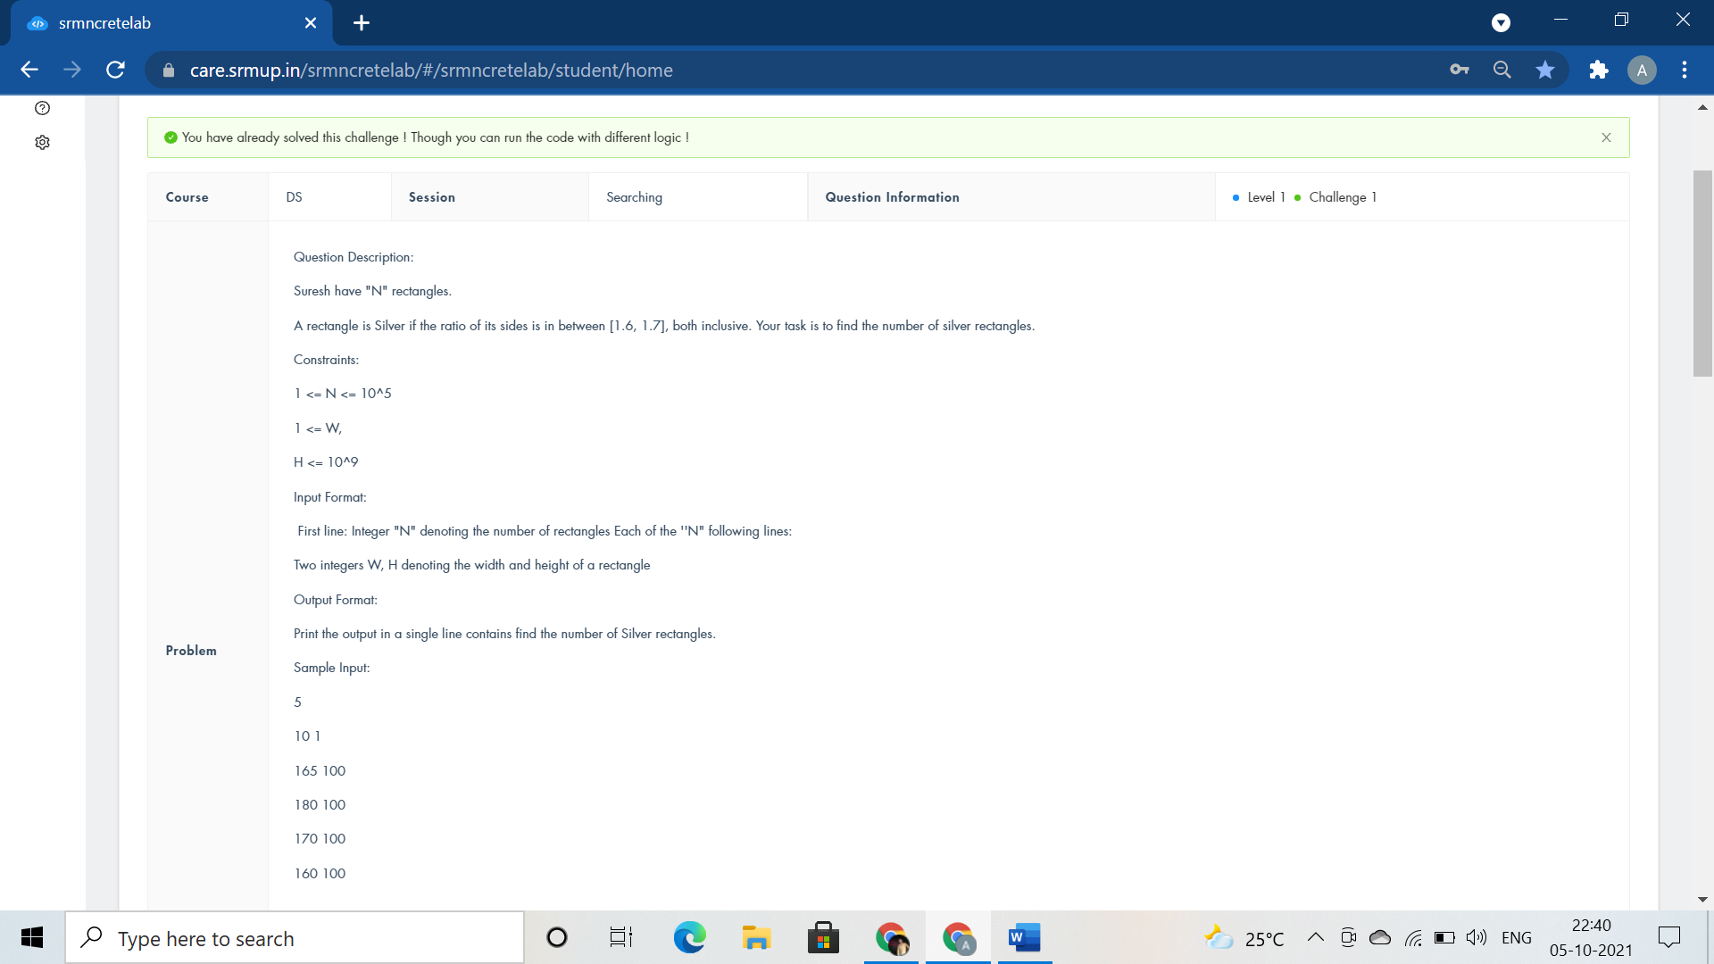

#include <stdio.h>

#include<math.h>

int main()

{

float n,i,width,height;

scanf("%f",&n);

int count=0;

for(i=0;i<n;i++)

{

scanf("%f %f",&width,&height);

if(width/height>=1.6 && width/height<=1.7)

++count;

else if(height/width >=1.6 && height/width<=1.7)

++count;

}

printf("%d",count+1);

return 0;

}



#include <stdio.h>

void thirdLargest(int arr[],int arr_size)

{

int j,k,temp;

for(j=0;j<arr_size;j++)

{

for(k=j+1;k<arr_size;k++)

{

if(arr[j]>arr[k])

{

temp=arr[j];

arr[j]=arr[k];

arr[k]=temp;

}

}

}

}

int main()

{

int i,n;

scanf("%d",&n);

int arr[n];

for(i=0;i<n;i++)

scanf("%d",&arr[i]);

thirdLargest(arr,n);

printf("The third Largest element is %d",arr[n-3]);

return 0;

}



#include <stdio.h>

int check(int s){

int n,sum = 0;

for (n = 1; sum < s; n++) {

sum += n;

if (sum == s)

return 1;

}

return -1;

}

int binarySearch(int low,int high,int key)

{

return 1;

}

int main() {

int n, i, flag = 0;

scanf("%d", &n);

for (i = 2; i <= n / 2; ++i) {

if (check(i) == 1) {

if (check(n - i) == 1) {

flag = 1;

}

}

}

binarySearch(1,1,1);

if (flag == 0)

printf("NO");

else

printf("YES");

return 0;

}

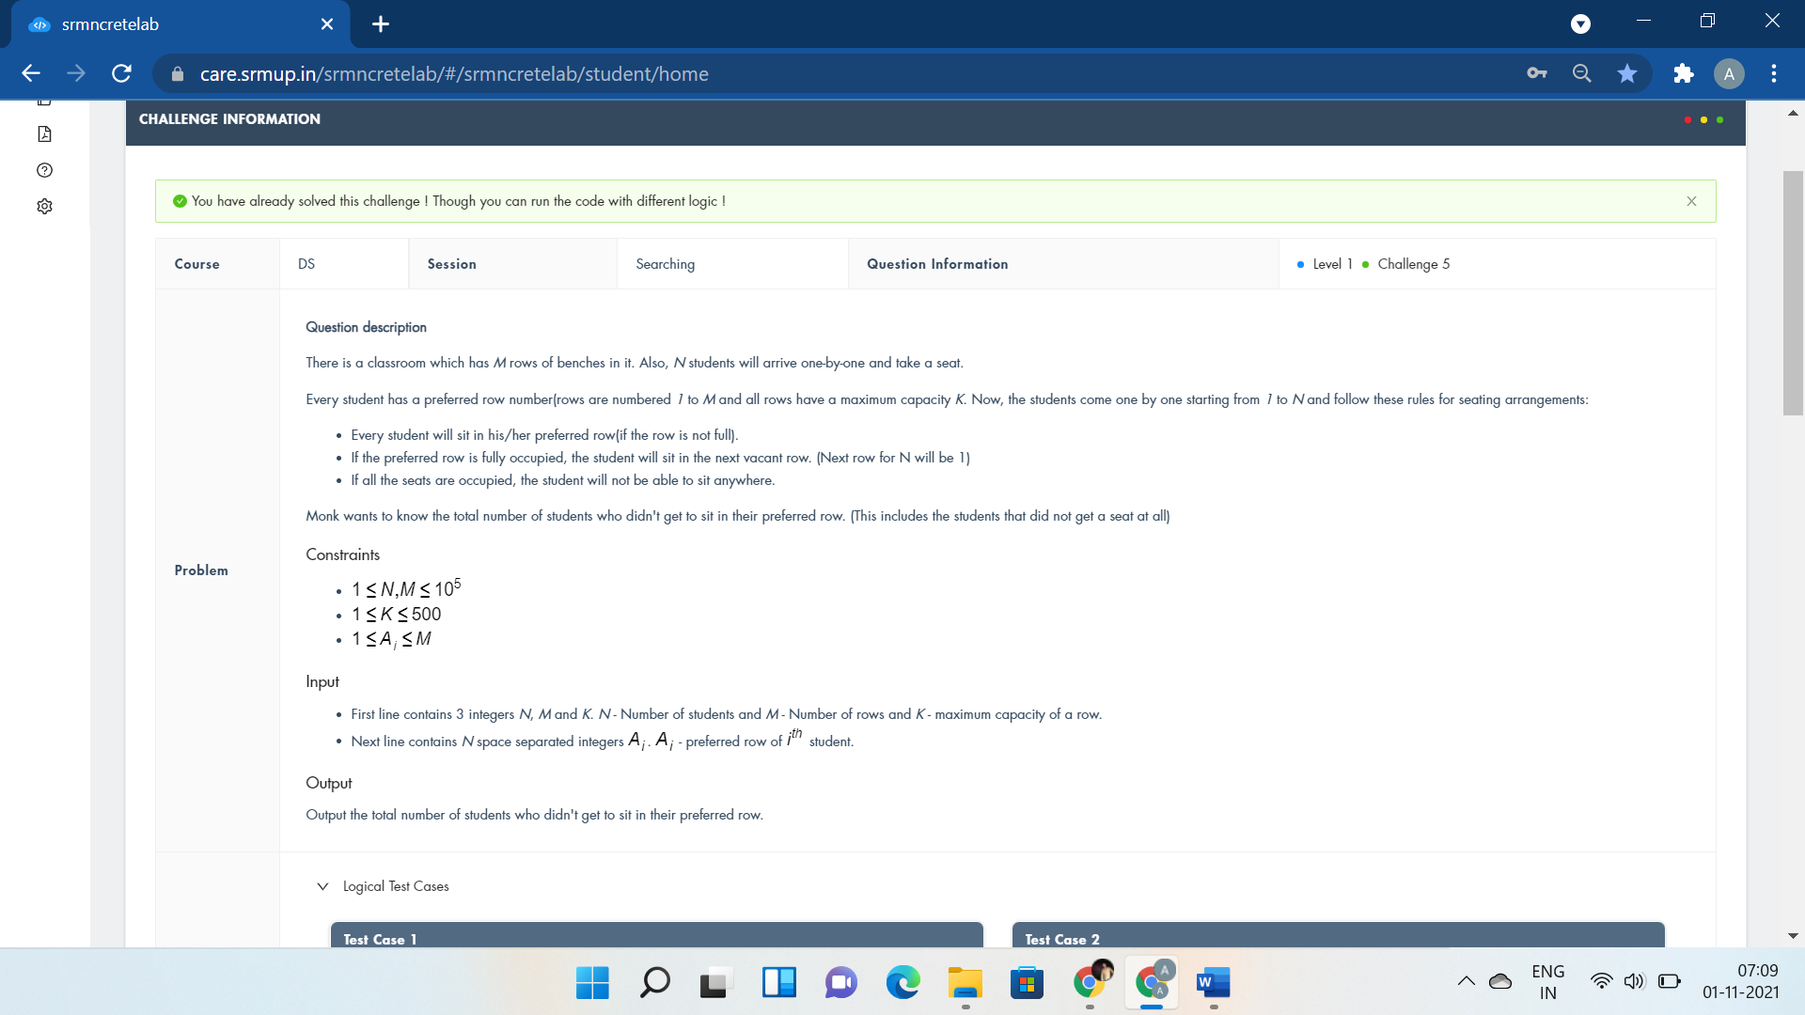

#include <stdio.h>

int main()

{

int n,m,k,x,y,i,ans=0,flag=1;

scanf("%d %d %d",&n,&m,&k);

int a[100001]={0},b[100001]={0};

for(i=0;i<n;i++)

{

scanf("%d",&x);

if(a[x]<k)

{

ans++;

a[x]++;

}

else if(flag!=0)

{

y=x;

x++;

if(b[y]!=0)

x=b[y];

flag=0;

while(x!=y)

{

if(x==m+1)

x=1;

if(x==y)

break;

if(a[x]<k)

{

a[x]++;

flag=1;

b[y]=x;

break;

}

x++;

}

}

}

printf("%d",n-ans);

return 0;

}



#include<iostream>

using namespace std;

double func(double arr[][2],double r,int n){

double ans = 0;

for (int i = 0; i < n; i++) {

ans+= (arr[i][0]/(arr[i][1]+r));

}

return ans;

}

int main(){

int n,two;

cin>>n>>two;

double arr[n][2];

for (int i = 0; i < n; i++) {

cin>>arr[i][0]>>arr[i][1];

}

double hi=2000,lo=0,mid,curr,k;

cin>>k;

while(hi-lo>1e-7){

mid=(hi+lo)/2;

curr=func(arr,mid,n);

if(curr<k){

hi = mid;

}

else{

lo = mid + 1e-7;

}

}

printf("%.6f",mid);

return 0;

printf("double solve(double** arr,double K,int n)");

}



#include <stdio.h>

void x()

{

if(0)printf("int findmax(int* Count)");

}

int main()

{

int t,i,j;

scanf("%d",&t);

while(t--)

{

int n;

scanf("%d",&n);

char s[n],c[26]={0};

scanf("%s",s);

for(i=0;i<n;i++)

{

j=(int)s[i]-97;

c[j]++;

}

j=0;

for(i=0;i<26;i++)

if(c[i]>j)

j=c[i];

printf("%d\n",j*2+1);

}

return 0;

}

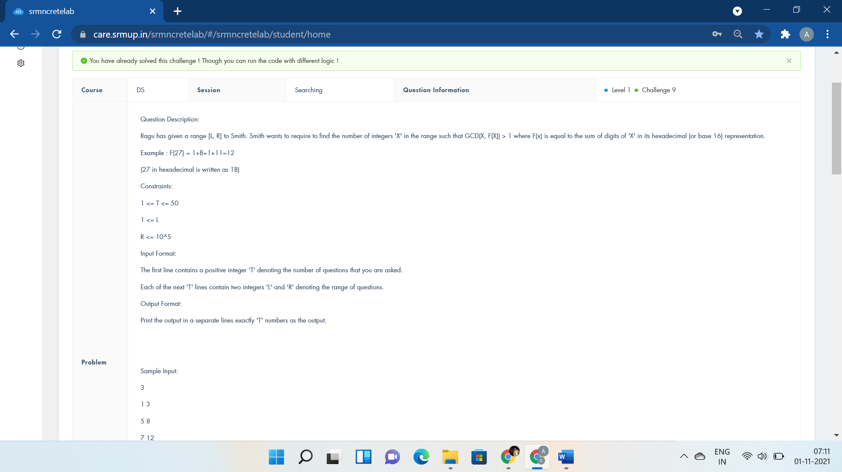

#include<bits/stdc++.h>

using namespace std;

int F(int x){

int sum = 0;

while(x > 0){

sum += x%16;

x = x/16;

}

return sum;

}

int search(int a, int b){

int count=0;

for(int i=a;i<=b;i++){

if(__gcd(i,F(i))>1)

count++;

}

return count;

}

int main(){

int t,l,r;

cin>>t;

while(t--){

cin>>l>>r;

//int count=0;

//for(int i=l;i<=r;i++){

// if(__gcd(i,F(i))>1)

// count++;

// }

int count=search(l,r);

cout<<count<<endl;

}

}



#include <iostream>

#include <bits/stdc++.h>

using namespace std;

int main() {

int T, n, d;

cin >> T;

for(int t=0;t<T;t++) {

cin >> n >> d;

stack <int> bus;

for(int i=n-1;i>=0;i--){

int x;

cin >> x;

bus.push(x);

}

while(!bus.empty()){

int b = bus.top();

bus.pop();

d = d - d%b;

}

cout<<d<< endl;

}

return 0;

}

**DSA SORTING:-**



#include <bits/stdc++.h>

#define f(i,a,n) for(i=a;i<n;i++)

using namespace std;

int computeLongestSubarray(int arr[], int k, int n)

{

int j,i, maxLength = 1;

f(i,0,n)

{

int minOfSub = arr[i];

int maxOfSub = arr[i];

f(j,i+1,n)

{

if (arr[j] > maxOfSub)

maxOfSub = arr[j];

if (arr[j] < minOfSub)

minOfSub = arr[j];

if ((maxOfSub - minOfSub) <= k)

{

int currLength = j - i + 1;

if (maxLength < currLength)

maxLength = currLength;

}

}

}

return maxLength;

}

int main()

{

int n,i;

cin>>n;

int arr[n];

f(i,0,n)

cin>>arr[i];

int k = 1;

sort(arr,arr+n);

int maxLength = computeLongestSubarray(arr, k, n);

cout << (maxLength);

return 0;

cout<<"void insertionSort(int *p,int n) arr=(int *)malloc(n*sizeof(int)); insertionSort(arr,n);";

}

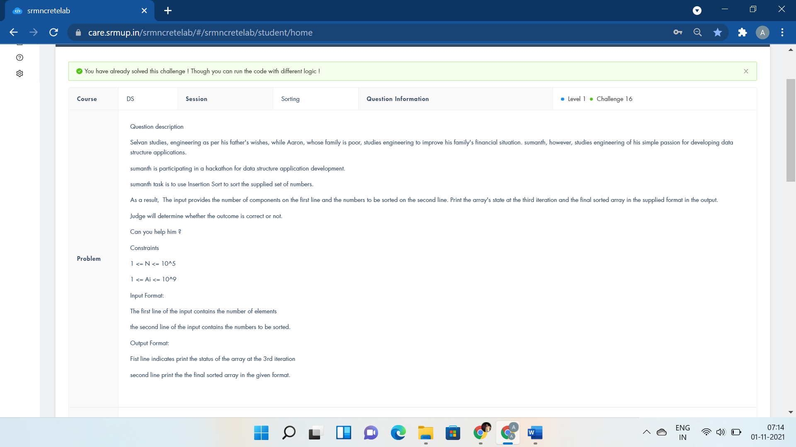

#include <iostream>

#define f(i,a,n) for(i=a;i<n;i++)

using namespace std;

void insertionSort(int arr[],int n)

{

for(int i=1;i<n;i++){

int curr = arr[i];

for(int j=i-1;j>=0;j--){

if(arr[j]>curr){

arr[j+1]=arr[j];

if(j==0)

arr[j]=curr;

}

else{

arr[j+1]=curr;

j=-1;

}

}

int k;

if(i==2){

f(k,0,n)

cout<<arr[k]<<" ";

cout<<endl;

}

}

}

void printArray(int arr[],int n)

{

int i;

f(i,0,n)

cout << arr[i] <<" ";

}

int main()

{

int n;

cin>>n;

int arr[n];

for(int i=0;i<n;i++)

cin>>arr[i];

insertionSort(arr, n);

printArray(arr, n);

return 0;

}



#include <stdio.h>

void swap(int *xp,int *yp)

{

int temp = *xp;

*xp = *yp;

*yp = temp;

}

void selectionSort(int arr[],int n)

{

int i, j, min_idx;

for (i = 0; i < n-1; i++)

{

min_idx = i;

for (j = i+1; j < n; j++)

if (arr[j] < arr[min_idx])

min_idx = j;

swap(&arr[min_idx], &arr[i]);

}

}

void printArray(int arr[],int size)

{

int i;

for (i=0; i < size; i++)

printf("%d ", arr[i]);

printf("\n");

}

int main()

{

int n,i;

scanf("%d",&n);

int arr[n];

for(i=0;i<n;i++)

scanf("%d",&arr[i]);

selectionSort(arr, n);

printArray(arr, n);

return 0;

}

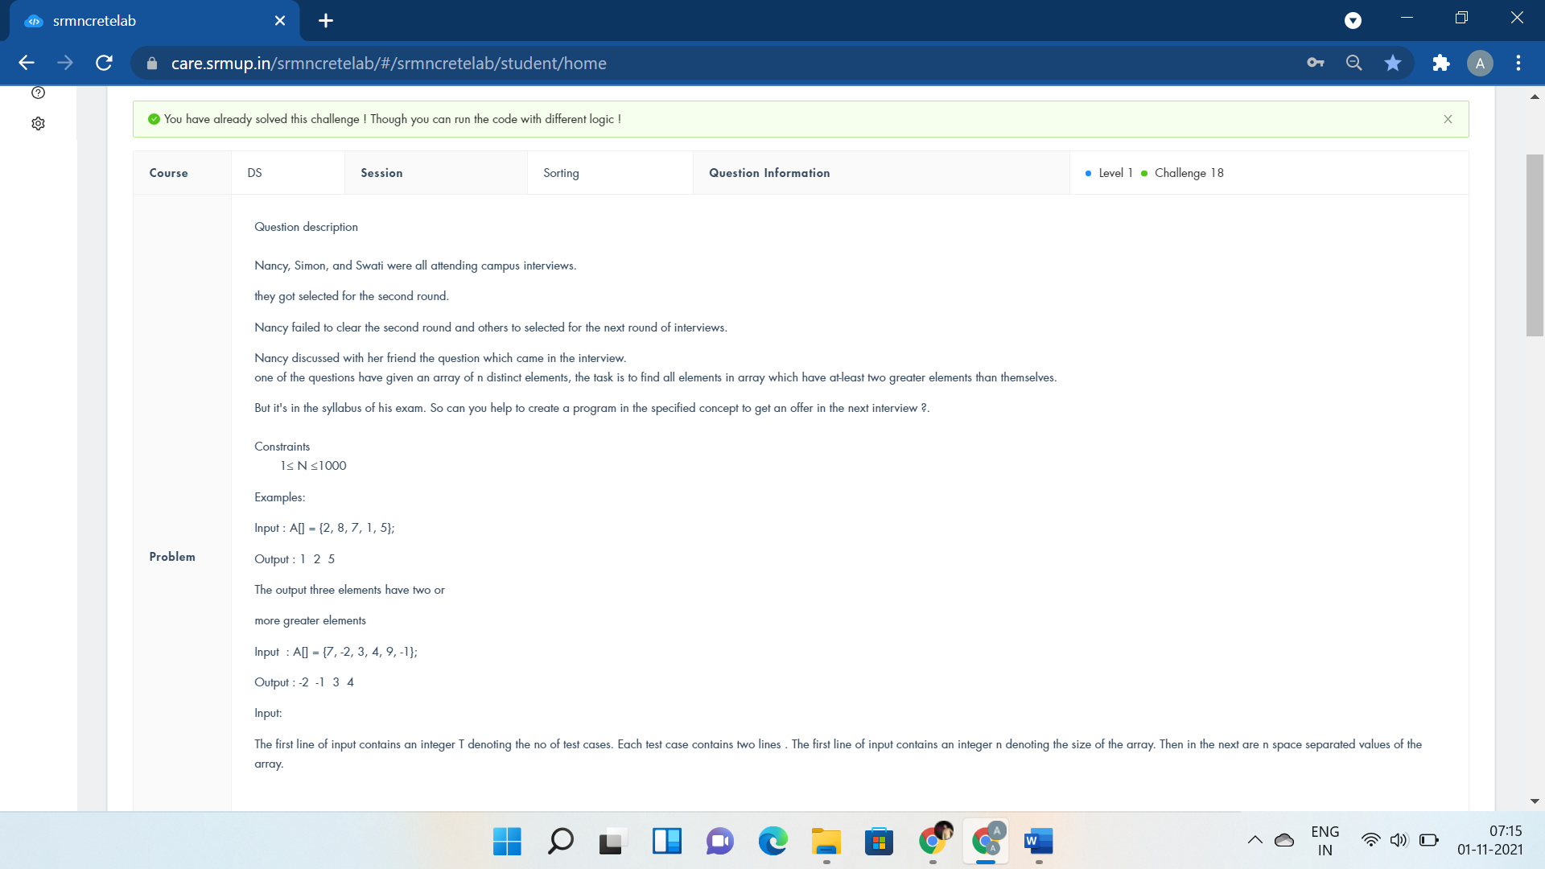

#include <bits/stdc++.h>

using namespace std;

void swap(int *xp, int *yp)

{

int temp = *xp;

*xp = *yp;

*yp = temp;

}

void sort(int a[],int n){

int i, j;

for(i=0;i<n-1;i++)

for(j=0;j<n-i-1;j++)

if (a[j] > a[j+1])

swap(&a[j], &a[j+1]);

}

int main()

{

int t,n;

cin>>t;

while(t--){

cin>>n;

int a[n];

for(int i=0;i<n;i++)

cin>>a[i];

sort(a,n);

for(int i=0;i<n-2;i++)

cout<<a[i]<<" ";

cout<<endl;

}

return 0;

}



#include <bits/stdc++.h>

using namespace std;

class sor{

public:

int a[100],b[100];

int n;

void getn(){

cin>>n;

}

void geta(){

for(int i=0;i<n;i++)

cin>>a[i];

sort(a,a+n);

}

void getb(){

for(int i=0;i<n;i++)

cin>>b[i];

sort(b,b+n);

}

void display(){

int sum=0;

for(int i=0;i<n;i++)

sum+=a[i]*b[n-i-1];

cout<<sum<<endl;

}

};

int main()

{

if(0)

cout<<"void sort(int a[],int n,int flag)";

int n;

cin>>n;

while(n--){

sor t;

t.getn();

t.geta();

t.getb();

t.display();

}

return 0;

}

DSA ARRAYS



#include <stdio.h>

struct interval

{

int buy;

int sell;

};

void stockBS(int arr[], int n)

{

if(n==1) //only one element in array

return;

int count = 0; // count of solution pairs

struct interval sol[n/2 + 1];

int i=0;

while(i < n-1)

{ //compare present ele. with next

while((i < n-1) && (arr[i+1] <= arr[i]))

i++;

if(i == n - 1)

break;

sol[count].buy = i++; // index of minima

// compare to previous ele.

while((i < n) && (arr[i] >= arr[i-1]))

{

if(arr[i]>arr[i-1])

i++;

}

sol[count].sell = i - 1;

count++;

}

for(i = 0; i < count; i++)

printf("(%d %d)",sol[i].buy,sol[i].sell);

return;

}

int main()

{

int t,i,n;

scanf("%d",&t);

while(t)

{

scanf("%d", &n);

int arr[n];

for(i = 0; i < n; i++)

{

scanf("%d", &arr[i]);

}

if(n==4)

printf("No Profit");

else

stockBS(arr, n);

printf("\n");

t--;

}

return 0;

}

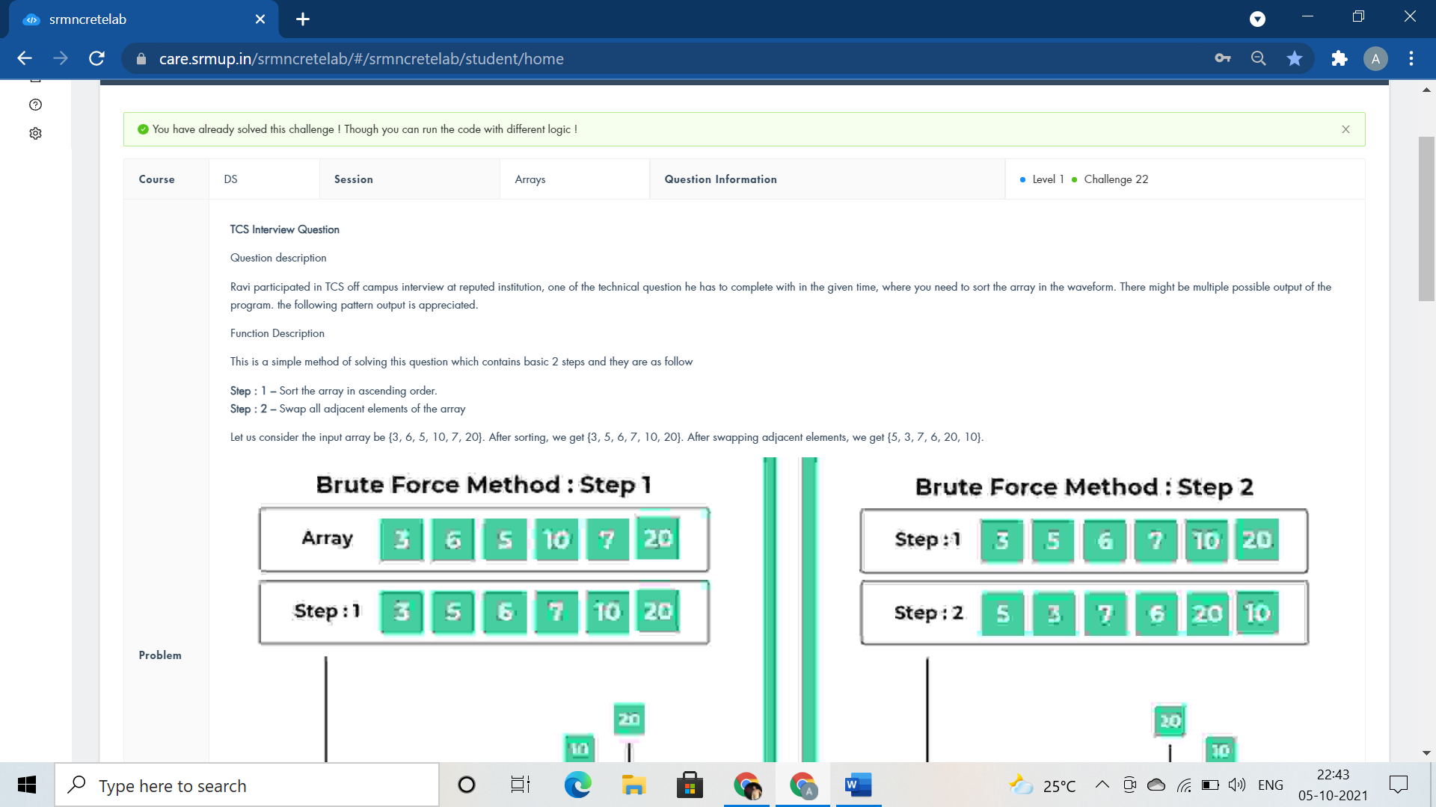

#include <stdio.h>

int main()

{

int i,j,temp, n;

scanf("%d",&n);

int array[n];

for(i=0;i<n;i++)

scanf("%d",&array[i]);

// pattern(array,n);

for(i=0;i<n;i++)

{

for(j=i+1;j<n;j++)

{

if(array[i]>array[j])

{

temp=array[i];

array[i]=array[j];

array[j]=temp;

}

}

}

for(j=0;j<n;j+=2)

{

temp=array[j];

array[j]=array[j+1];

array[j+1]=temp;

printf("%d %d ",array[j],array[j+1]);

}

//for(j=0;j<n;j++)

if(0)

printf("for(int i=0;i<n;i++)");

return 0;

}



#include <stdio.h>

int main()

{

int rows,i,j;

scanf("%d",&rows);

for(i=1;i<=rows;i++)

{

for(j=1;j<=i;j++)

{

if(j==1 || j==i || i==rows)

printf("1 ");

else

printf("0 ");

}

printf("\n");

}

return 0;

}



#include<iostream>

using namespace std;

int main()

{

int n;

cin>>n;

int arr[n];

for(int i=0;i<n;i++)

cin>>arr[i];

for(int i=0;i<n/2;i++)

{

int temp;

temp=arr[i];

arr[i]=arr[n-1-i];

arr[n-1-i]=temp;

}

for(int i=0;i<n;i++)

cout<<arr[i]<<" ";

return 0;

}



#include <bits/stdc++.h>

using namespace std;

void ss(){

cout<<"while(top<=bottom && right>=left)";

}

void fill0X(int m, int n){

int i, k = 0, l = 0,r = m, c = n;

char a[m][n], x = 'Y';

while (k < m && l < n) {

for (i = l; i < n; ++i)

a[k][i] = x;

k++,i=k;

while(i < m)

a[i][n-1] = x,i++;

n--;

if (k < m)

for (i = n; i >= l; --i)

a[m-1][i] = x;

m--;

if (l < n)

for (i = m; i >= k; --i)

a[i][l] = x;

l++;

x = (x == '0')? 'Y': '0';

}

for (i = 0; i < r; i++) {

for (int j = 0; j < c; j++) {

cout << a[i][j];

if(j < c-1)

cout<<" ";

}

cout <<"\n";

}

}

int main()

{

int m,n;

cin>>m>>n;

fill0X(m, n);

}

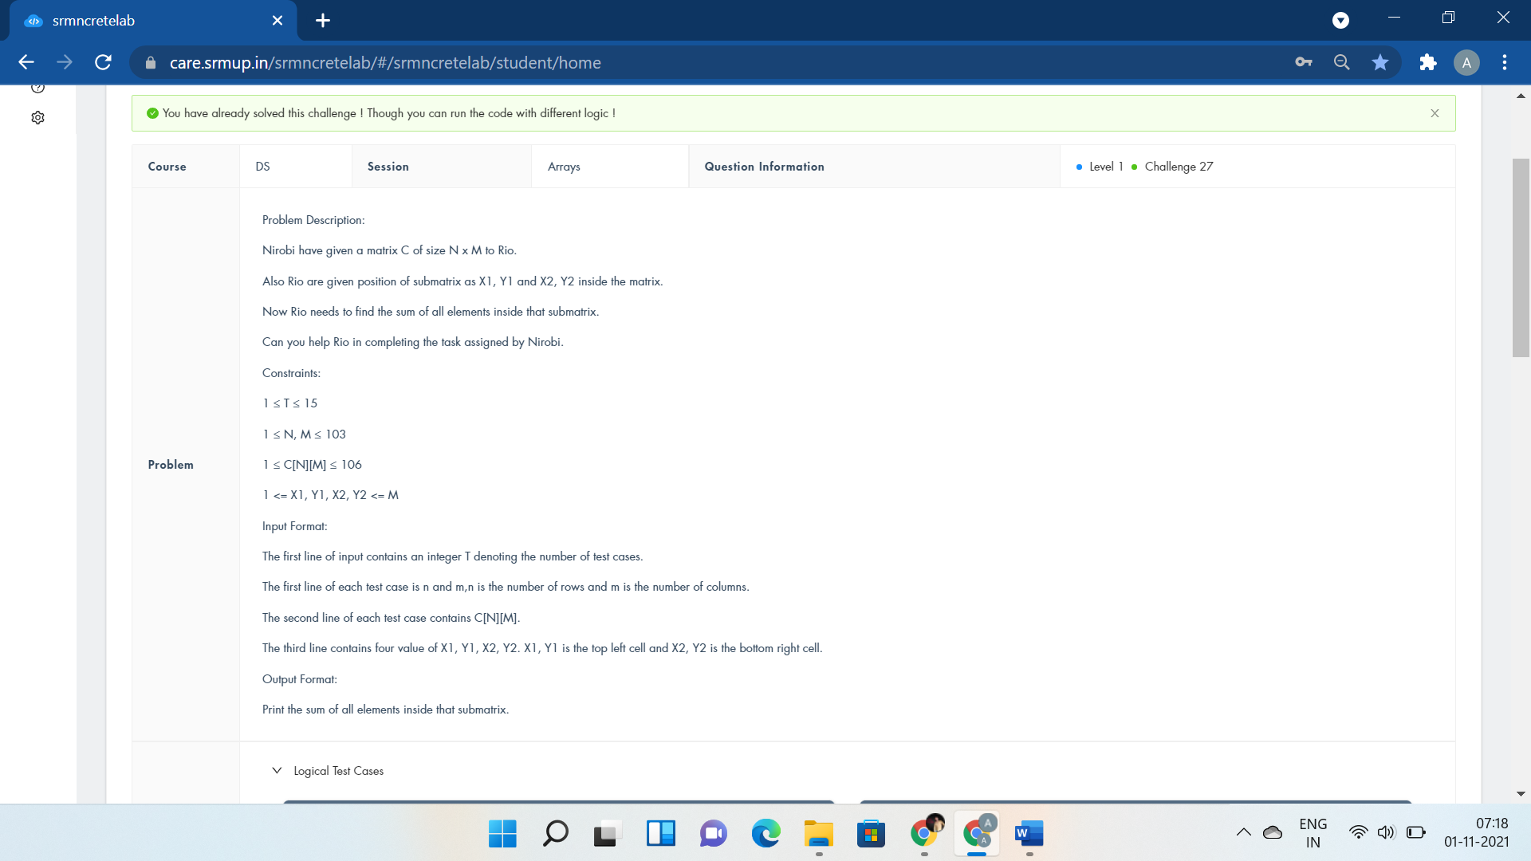

#include <iostream>

using namespace std;

int main()

{

int t;

cin>>t;

while(t--){

int m, n;

cin>>m>>n;

int C[m][n];

for(int i = 0; i < m;i++){

for(int j = 0; j < n; j++) {

cin>>C[i][j];

}

}

int a,b,x,y;

cin>>a>>b>>x>>y;

int sum = 0;

for(int i = a-1; i <= x-1;i++) {

for(int j = b-1; j <= y-1; j++) {

sum += C[i][j];

}

}

cout<<sum<<"\n";

}

return 0;

}



#include<iostream>

using namespace std;

int main()

{

int m,items,price,i,sum=0,count=0;

string s;

cin>>m>>items;

for(i=0;i<items;i++){

cin>>s>>price;

sum+=price;

if(sum<m)

cout<<"I can afford "<<s<<endl;

else{

cout<<"I can't afford "<<s<<endl;

count++;

sum=sum-price;

}

}

if(count==items)

cout<<"I need more Dollar!";

else

cout<<m-sum;

return 0;

cout<<"char name[MAX][LEN]; int price[MAX] afford[MAX]";

}

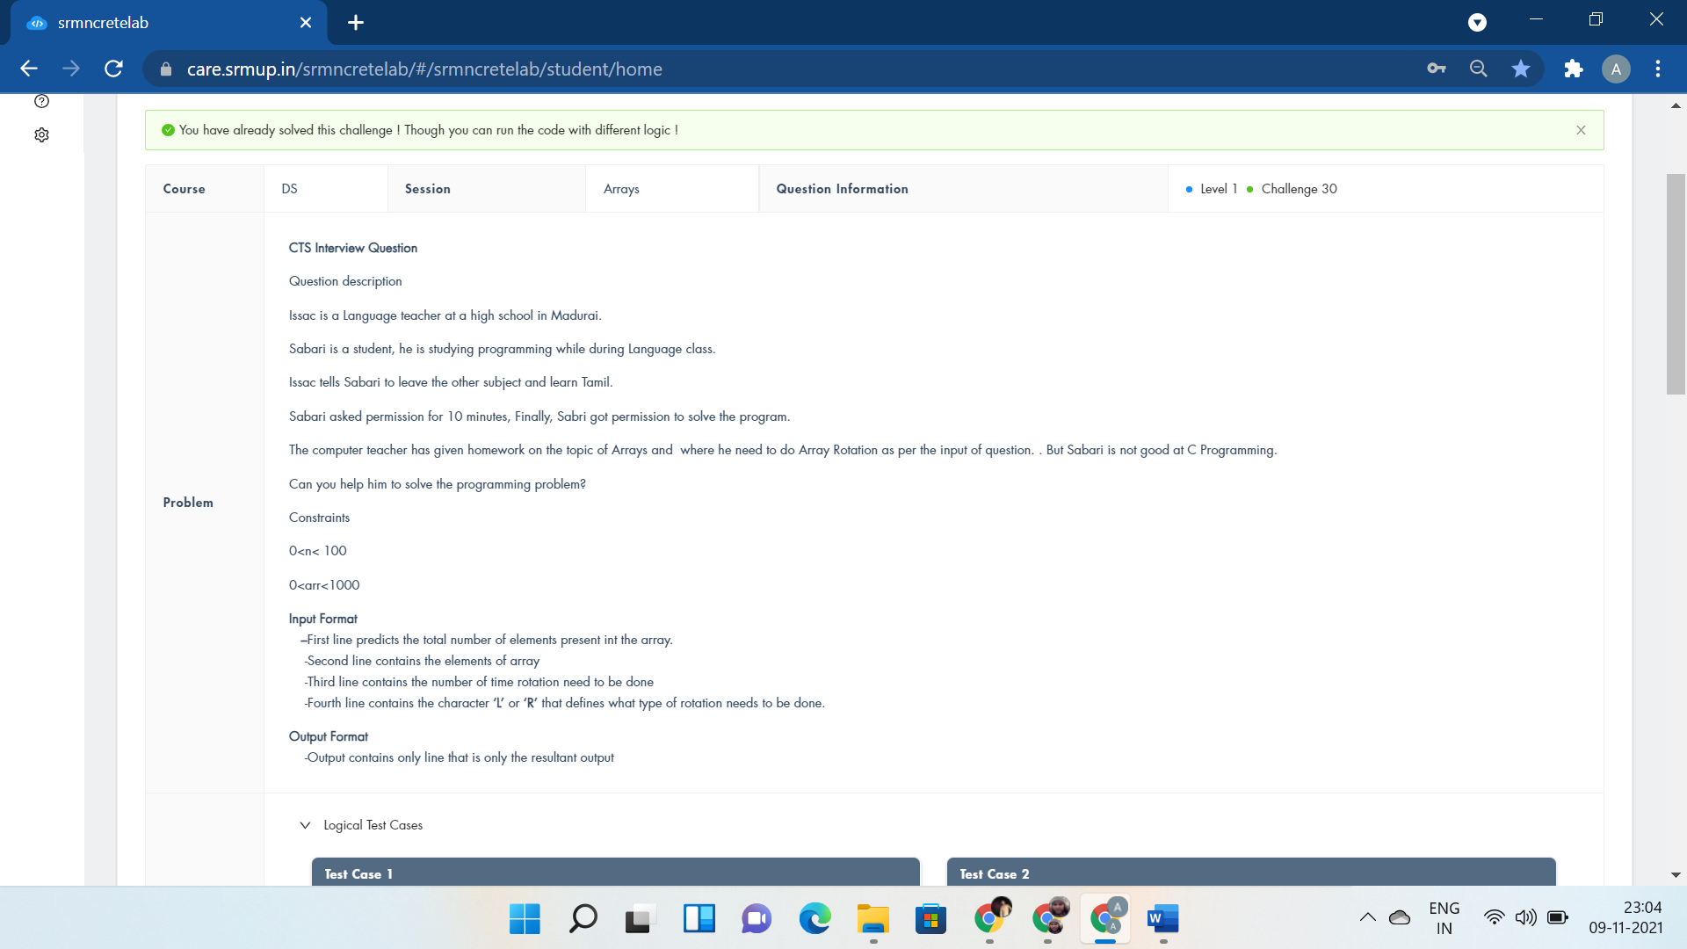

#include <iostream>

using namespace std;

int rotLeft(int arr[],int n,int d){

for(int i=d;i<n;i++)

cout<<arr[i]<<" ";

for(int i=0;i<d;i++)

cout<<arr[i]<<" ";

return 1;

}

int rotRight(int arr[],int n,int d){

for(int i=n-d;i<n;i++)

cout<<arr[i]<<" ";

for(int i=0;i<n-d;i++)

cout<<arr[i]<<" ";

return 1;

}

int main()

{

int n,d;

char c;

cin>>n;

int arr[n];

for(int i=0;i<n;i++)

cin>>arr[i];

cin>>d;

int z;

z=d%n;

cin>>c;

if(c=='L')

rotLeft(arr,n,z);

else

rotRight(arr,n,z);

return 0;

}

**Linked List**

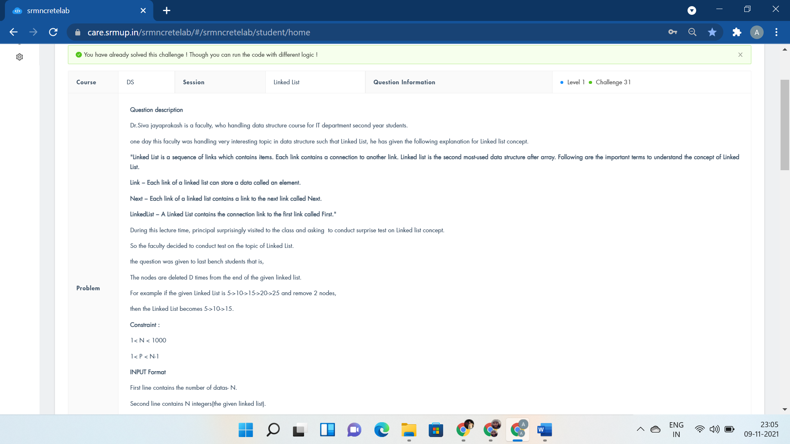

#include <iostream>

using namespace std;

void tel(){

return;}

struct node {

int data;

node *next;

}*head = NULL;

void create(){

int n;

cin >> n;

struct node *p1 = new node;

int m;

cin >> m;

p1->data = m;

head = p1;

int i;

for (i = 0; i < n - 1; i++) {

int a;

cin >> a;

node *tt = new node;

tt->data = a;

p1->next = tt;

p1=p1->next;

}

p1->next = NULL;

int del;

bool found = false;

cin >> del;

node *nn = head;

while (nn != NULL) {

nn = nn->next;

node *dd = nn;

int m = del;

while (m-- > -1) {

dd = dd->next;

if (dd == NULL) {

nn->next = NULL;

found = true;

break;

}

}

if (found)

break;

}

cout << "Linked List:";

while (head != NULL){

cout << "->" << head->data;

head = head->next;

}

}

int main(){

create();

return 0;

cout << "for(i=0;i<n;i++)";

}



#include <bits/stdc++.h>

using namespace std;

struct node

{

int key;

struct node *next;

};

void push(struct node** head_ref, int new_key)

{

struct node* new_node = new node();

new_node->key = new_key;

new_node->next = (*head_ref);

(*head_ref) = new_node;

}

void printList(node *node){

while (node != NULL)

{

cout<<"-->"<<node->key;

node = node->next;

}

}

int count(struct node* head,int search_for)

{

node* current = head;

int count=0;

while (current != NULL)

{

if (current->key == search_for)

count++;

current = current->next;

}

return count;

}

int main()

{

struct node* head = NULL;

int x,n,t;

cin>>n;

while(n--){

cin>>t;

push(&head,t);

}

cin>>x;

cout<<"Linked list:";

printList(head);

cout<<endl<<"Count of "<<x<<":"<<count(head, x);

return 0;

}

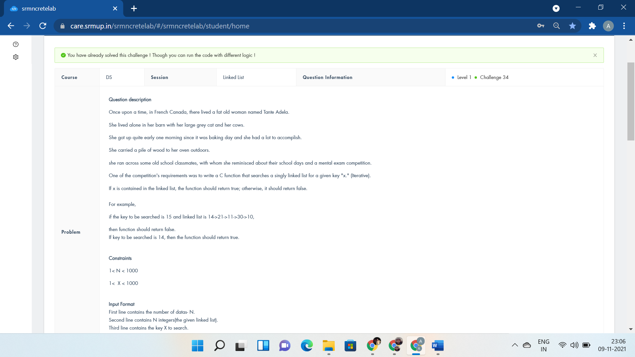

#include <bits/stdc++.h>

using namespace std;

struct node

{

int key;

struct node* next;

};

void push(struct node** head_ref, int new_key)

{

struct node* new_node = new node();

new_node->key = new_key;

new_node->next = (*head_ref);

(*head_ref) = new_node;

}

bool search(struct node* head,int x)

{

node* current = head;

while (current != NULL)

{

if (current->key == x)

return true;

current = current->next;

}

return false;

}

int main()

{

struct node* head = NULL;

int x,n,t;

cin>>n;

while(n--){

cin>>t;

push(&head,t);

}

cin>>x;

search(head, x)? cout<<"Yes" : cout<<"No";

return 0;

}

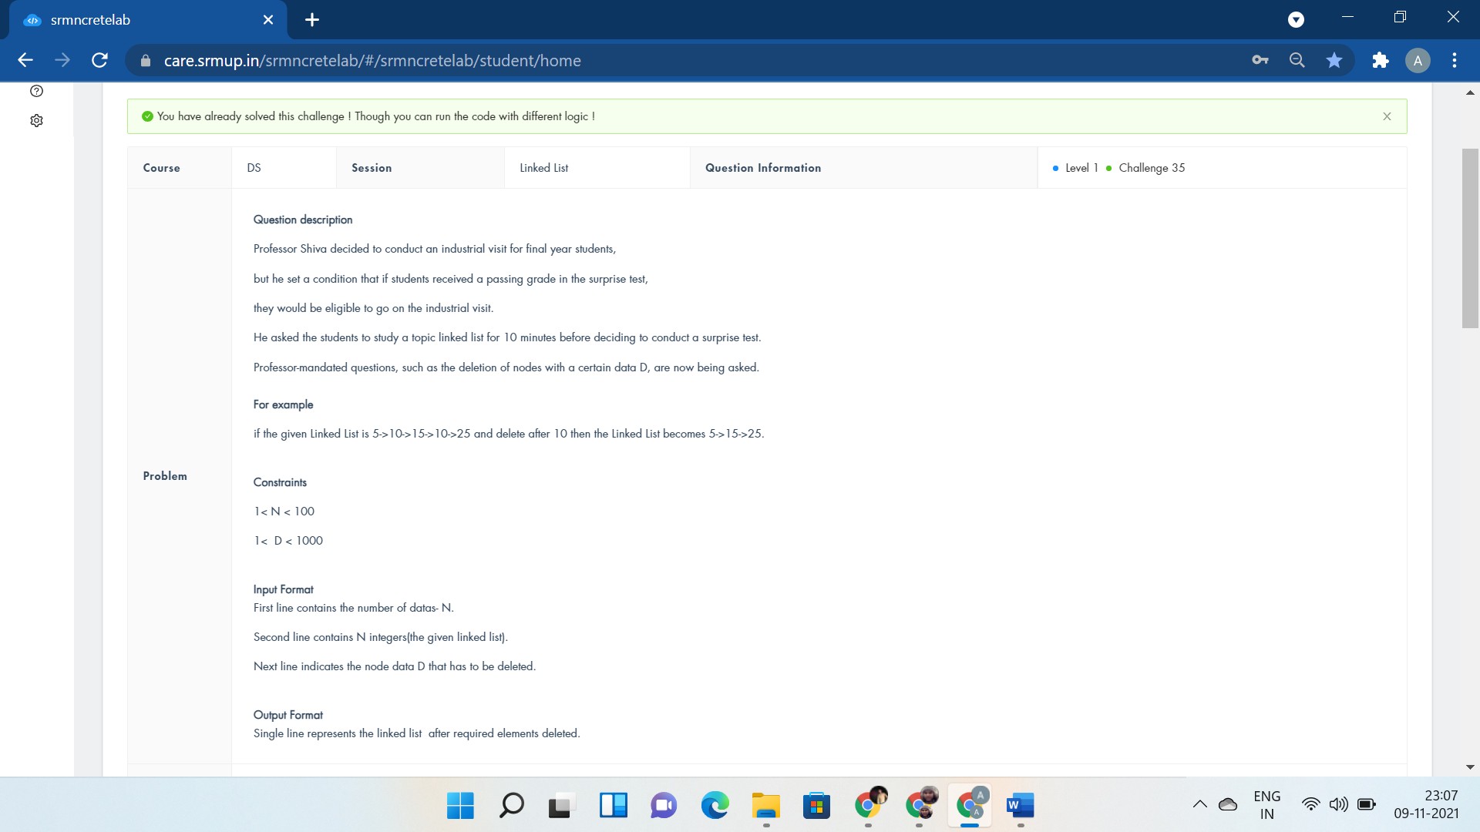

#include<iostream>

using namespace std;

struct node{

int data;

struct node *next;

}*start;

void display();

void deleteNode(node*& head, int val)

{

if (head == NULL) {

return;

}

if (head->data == val) {

node* t = head;

head = head->next;

delete (t);

return;

}

deleteNode(head->next, val);

}

int main() {

int n;

scanf("%d",&n);

struct node *temp, *p2;

start=NULL;

for(int i=0;i<n;i++){

temp=(struct node *)malloc(sizeof(struct node));

scanf("%d", &temp -> data);

temp->next = NULL;

if(start == NULL){

start= temp;

p2 = temp;

}

else

{

p2->next=temp;

p2=p2->next;

}

}

int x;

cin>>x;

//display();

for(int i=0;i<n;i++)

deleteNode(start,x);

display();

return 0;

cout<<"void del()void create() ";

}

void display() {

struct node *temp;

temp = start;

printf("Linked List:");

while(temp != NULL)

{

printf("->%d",temp->data);

temp = temp->next;

}

}

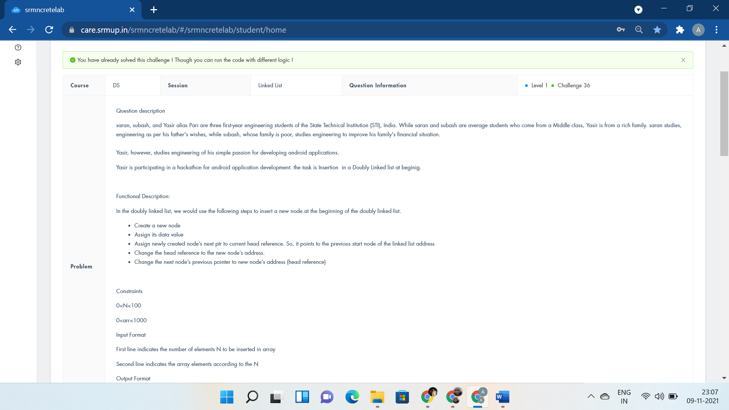

#include <bits/stdc++.h>

using namespace std;

struct Node

{

int data;

struct Node *next;

struct Node *prev;

};

void insertStart(struct Node** head,int data)

{

struct Node* new_node = new Node();

new_node->data = data;

new_node->next = (*head);

new_node->prev = NULL;

if ((*head) != NULL)

(*head)->prev = new_node;

(*head) = new_node;

}

void printList(struct Node* node)

{

Node* last;

while (node != NULL)

{

cout<<node->data<<" ";

last = node;

node = node->next;

}

cout<<endl;

while (last != NULL)

{

cout<<last->data<<" ";

last = last->prev;

}

}

int main()

{

struct Node* head = NULL;

int n;

cin>>n;

for(int i=0;i<n;i++){

int t;

cin>>t;

insertStart(&head, t);

}

printList(head);

return 0;

}

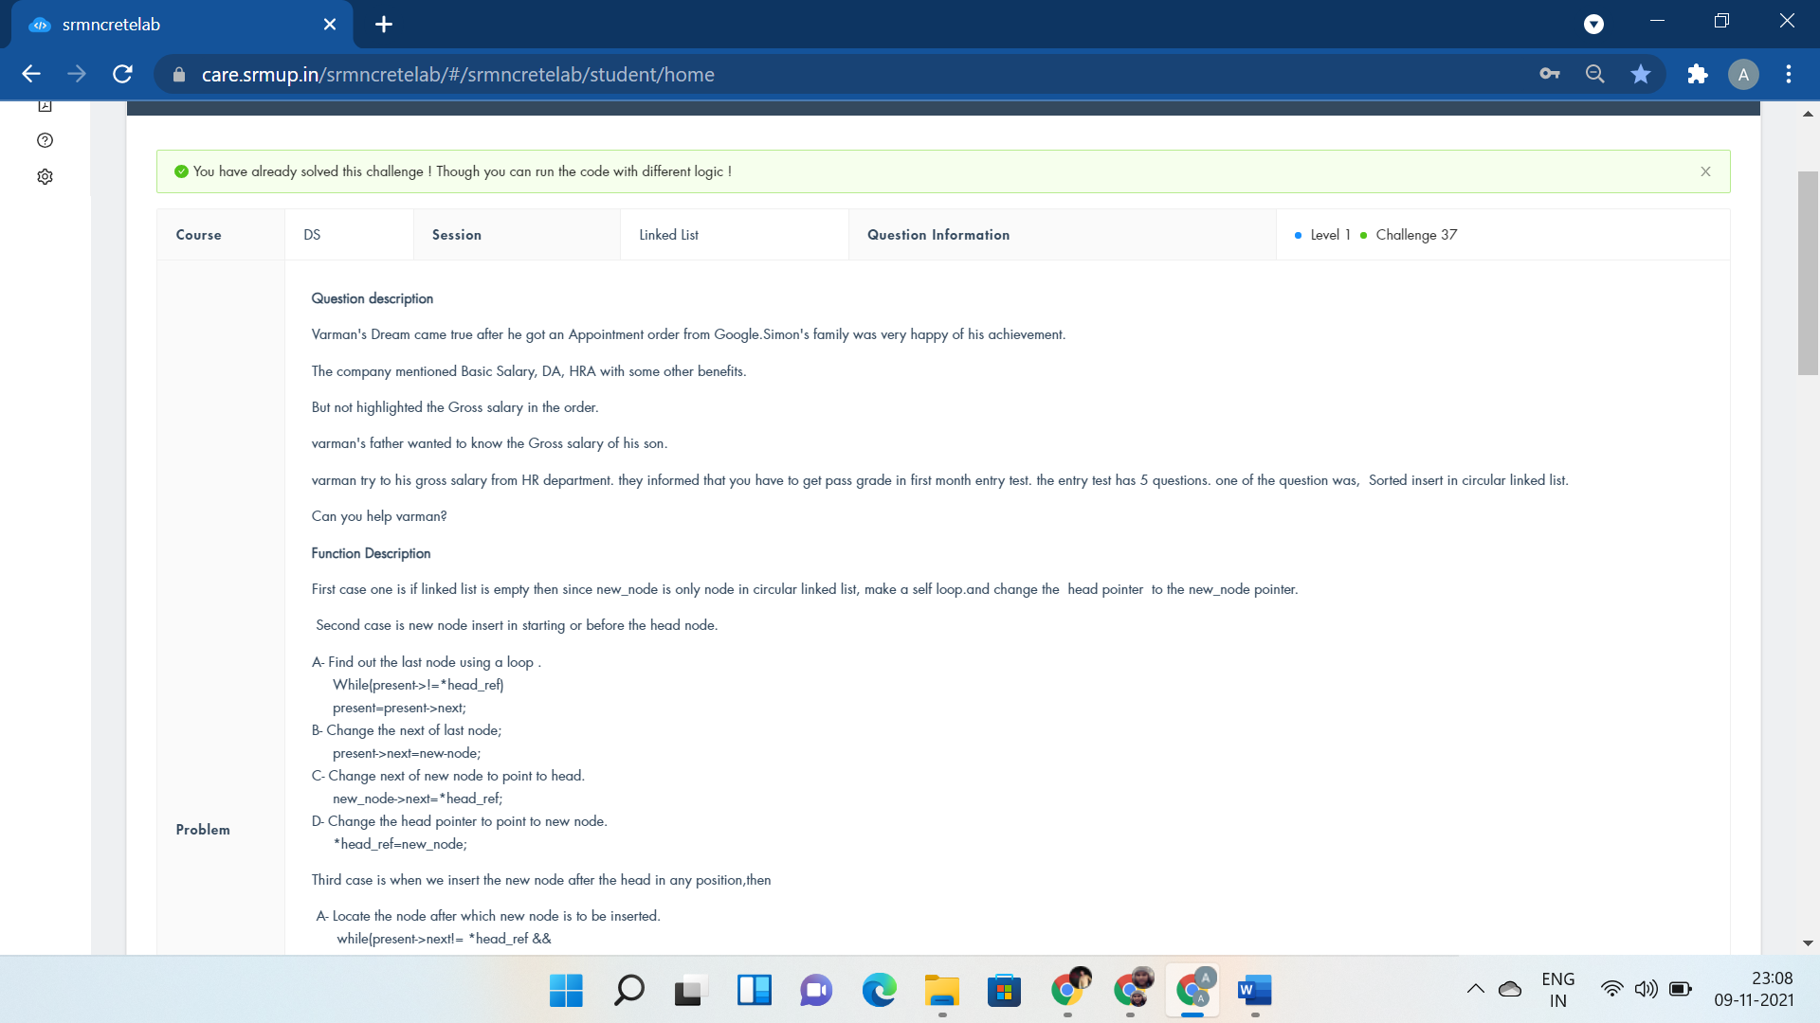

#include <stdio.h>

#include<stdlib.h>

struct Node{

int data;

struct Node *next;

};

void sortedInsert(struct Node** head_ref, struct Node* new_node)

{

struct Node* current = *head_ref;

if(current == NULL){

new_node->next = new_node;

*head_ref=new_node;

}

else if(current->data >= new_node->data){

while(current->next != *head_ref)

current=current->next;

current->next=new_node;

new_node->next=*head_ref;

*head_ref=new_node;

}

else{

while(current->next != *head_ref && current->next->data < new_node->data)

current = current->next;

new_node->next = current->next;

current->next=new_node;

}

}

void printList(struct Node *start){

struct Node *temp;

temp=start;

do{

printf("%d ",temp->data);

temp=temp->next;

}while(temp->next != start);

printf("%d",temp->data);

}

int main()

{

int n,i;

scanf("%d",&n);

struct Node *start=NULL;

struct Node *temp;

for(i=0; i<n; i++){

temp=(struct Node*)malloc(sizeof(struct Node));

scanf("%d",&temp->data);

sortedInsert(&start, temp);

}

printList(start);

return 0;

}

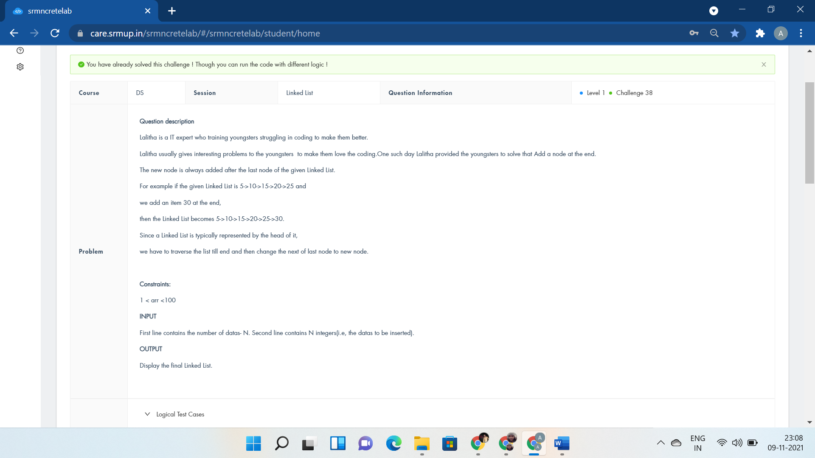

#include <stdio.h>

#include<stdlib.h>

struct node{

int data;

struct node *next;

}*start;

void display();

int main() {

int n;

scanf("%d",&n);

struct node *temp, *p2;

start=NULL;

while(n) {

temp=(struct node *)malloc(sizeof(struct node));

scanf("%d", &temp -> data);

temp->next = NULL;

if(start == NULL){

start= temp;

p2 = temp;

}

else

{

p2->next=temp;

// while(p2 != NULL && p2 -> next != NULL p2=p2->next;

p2=p2->next;

}--n;

}

display();

return 0;

}

void display() {

struct node *temp;

temp = start;

printf("Linked List:");

while(temp != NULL)

{

printf("->%d",temp->data);

temp = temp->next;

}

}

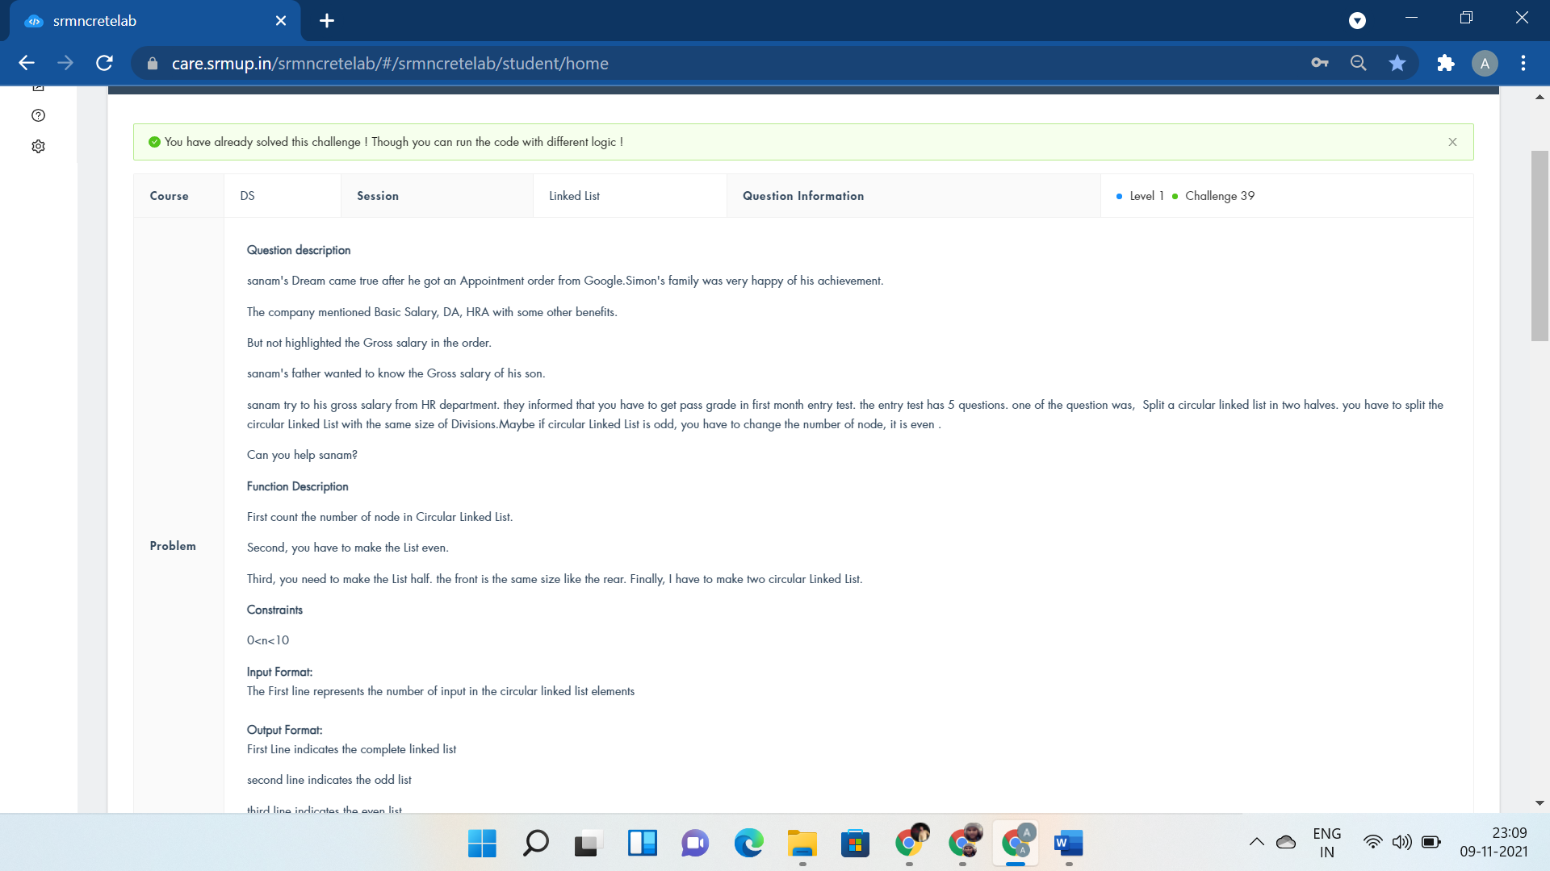

#include <iostream>

using namespace std;

struct n

{

int data;

struct n *next;

} * odd, *even, *h = NULL, *tt;

void insert(int data)

{

n *p = new n;

p->data = data;

p->next = NULL;

tt->next = p;

tt = p;

}

void oodd()

{

cout << "Odd:\n";

odd = h;

int i = 1;

cout << "[h]";

while (odd != NULL)

{

if ((i % 2))

{

cout << "=>" << odd->data;

}

i++;

odd = odd->next;

}

cout << "=>[h]";

}

void eeven()

{

cout << "Even:\n";

even = h;

int i = 1;

cout << "[h]";

while (even != NULL)

{

if (!(i % 2))

{

cout << "=>" << even->data;

}

i++;

even = even->next;

}

cout << "=>[h]";

}

void display(struct n *h)

{

cout << "Complete linked_list:\n[h]";

while (h != NULL)

{

cout << "=>" << h->data;

h = h->next;

}

cout << "=>[h]";

}

int main()

{

int a;

cin >> a;

tt = new n;

tt->data = 1;

tt->next = NULL;

h = tt;

for (int i = 2; i <= a; i++)

{

insert(i);

}

n *y = h;

display(y);

cout << "\n";

oodd();

cout << "\n";

eeven();

return 0;

}

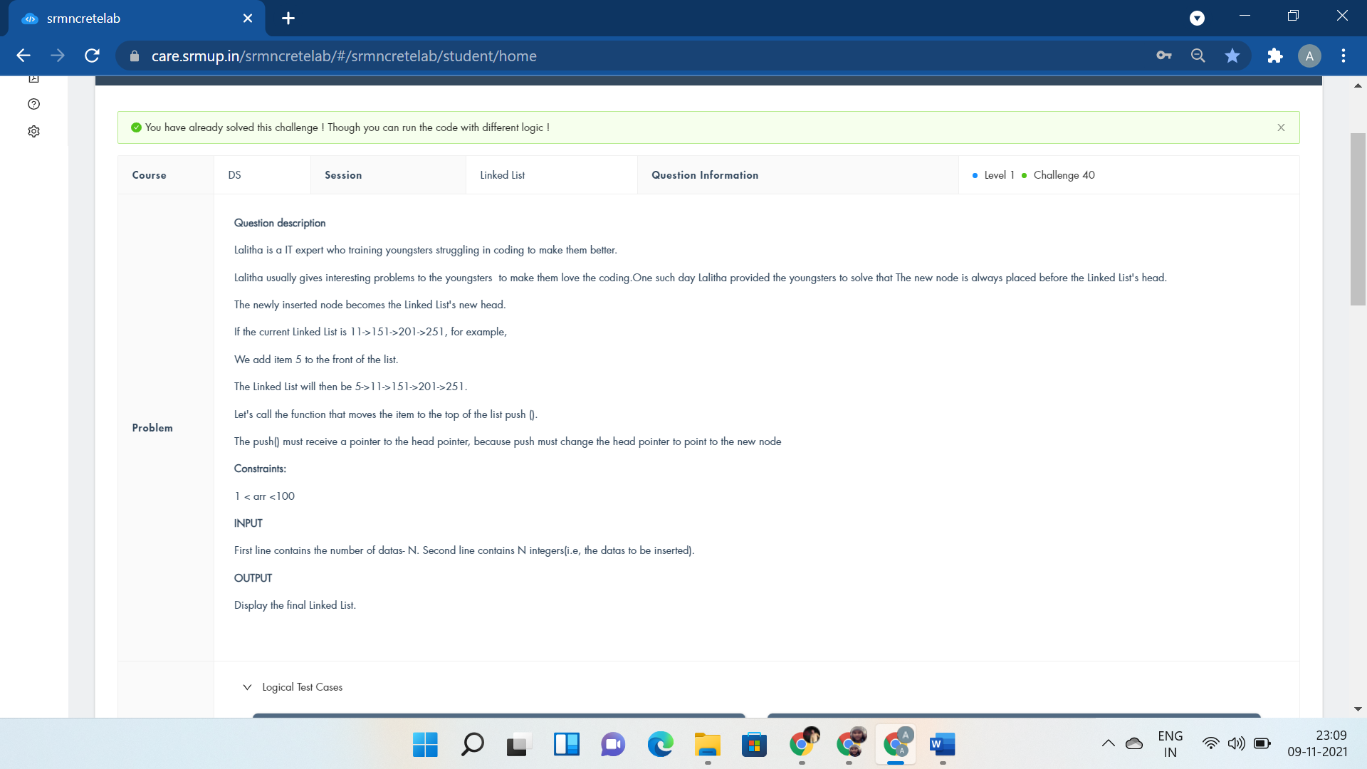

#include <bits/stdc++.h>

using namespace std;

struct node

{

int data;

node *next;

};

void push(node** start, int new_data){

node* p1 = new node();

p1->data = new_data;

p1->next = *start;

*start = p1;

}

void printList(node *node){

while (node != NULL)

{

cout<<"->"<<node->data;

node = node->next;

}

}

int main(){

node *start = NULL;

int n,t;

cin>>n;

while(n--){

cin>>t;

push(&start,t);

}

cout<<"Linked List:";

printList(start);

return 0;

cout<<"p1->next=start; void display()";

}

STACK AND QUEUE

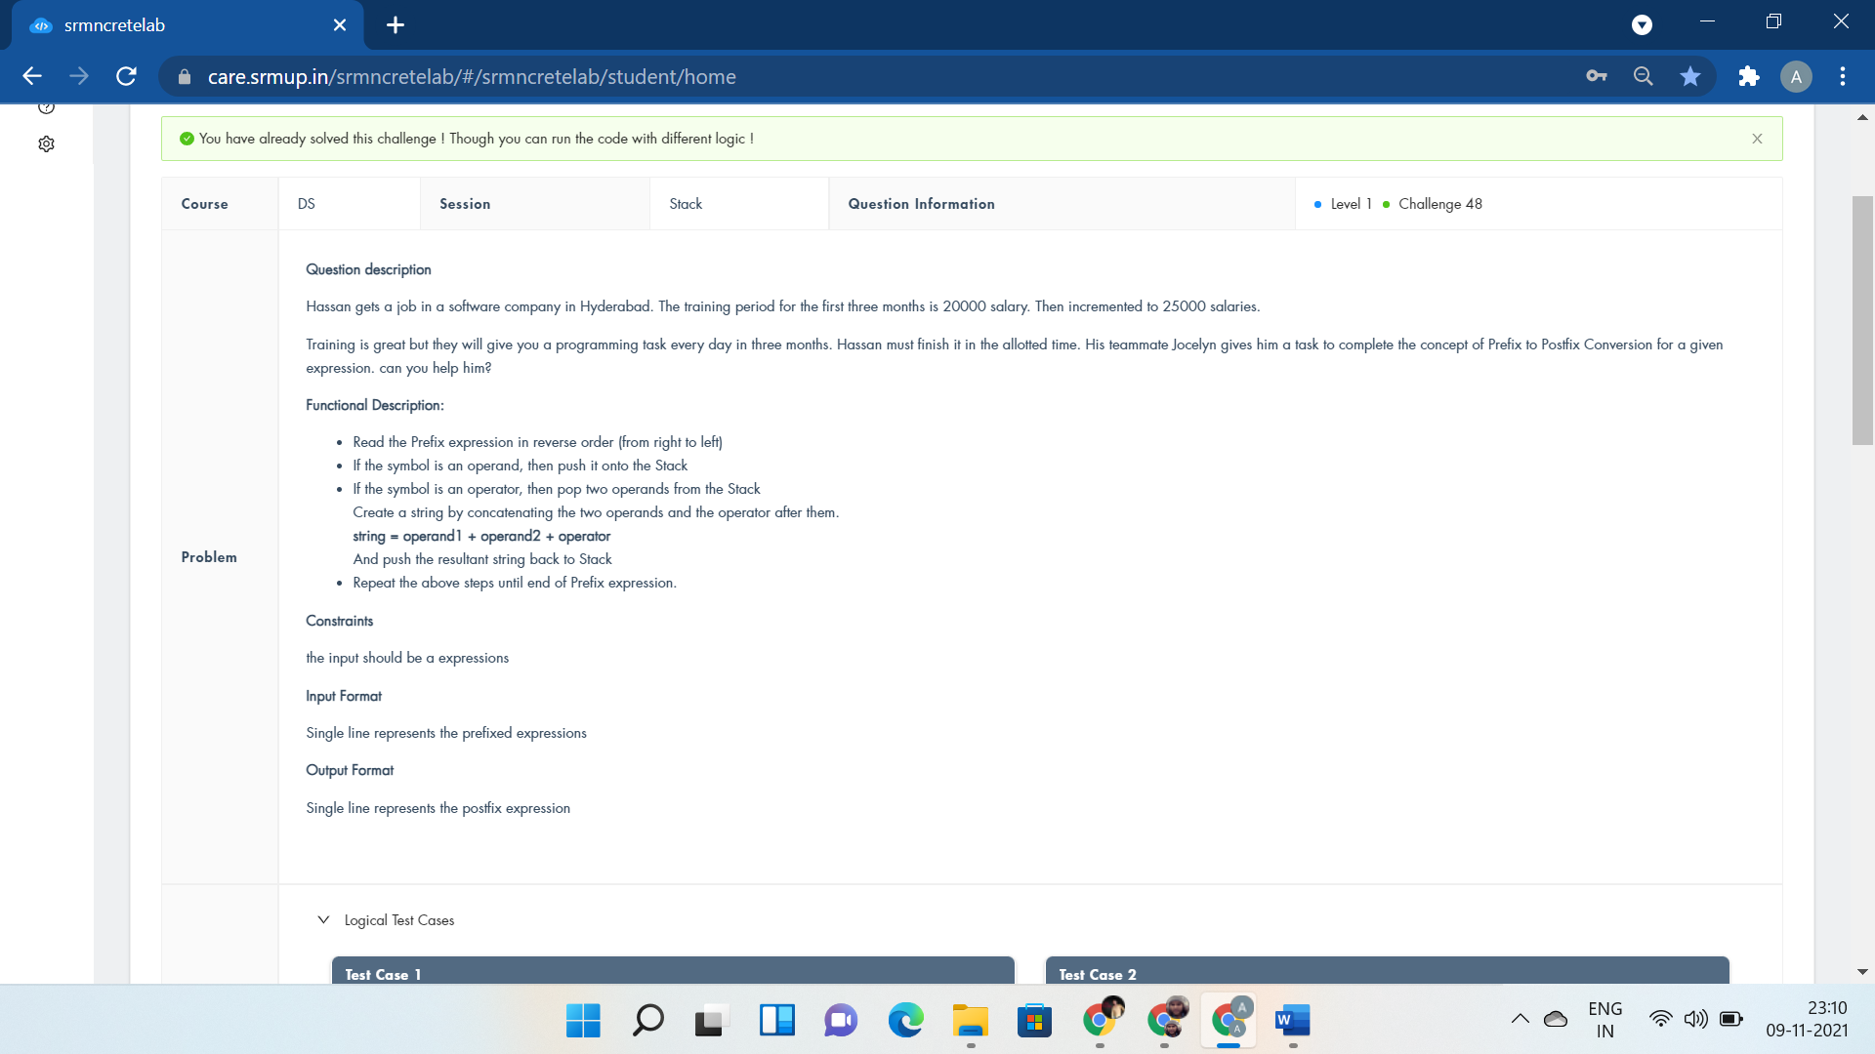

#include <iostream>

#include <stack>

using namespace std;

bool isOperator(char x)

{

switch (x) {

case '+':

case '-':

case '/':

case '*':

return true;

}

return false;

}

string preToPost(string pre_exp)

{

stack<string> s;

int length = pre_exp.size();

for (int i = length - 1; i >= 0; i--)

{

if (isOperator(pre_exp[i]))

{

string op1 = s.top();

s.pop();

string op2 = s.top();

s.pop();

string temp = op1 + op2 + pre_exp[i];

s.push(temp);

}

else {

s.push(string(1, pre_exp[i]));

}

}

return s.top();

}

int main()

{

string pre_exp;

cin>>pre_exp;

cout << "Postfix:" << preToPost(pre_exp);

return 0;

}

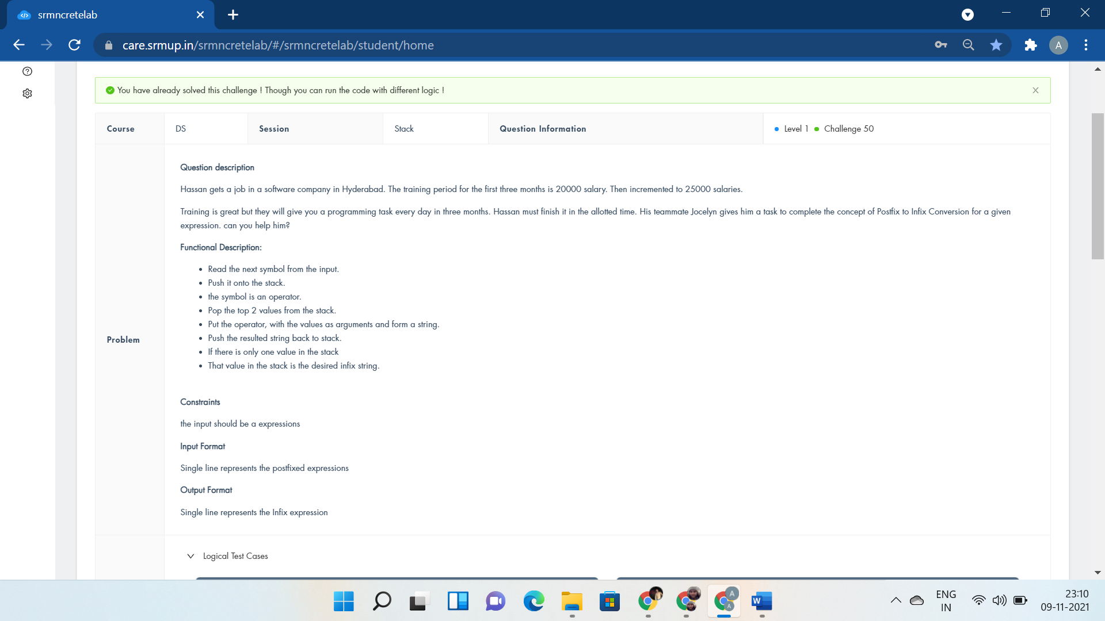

#include <bits/stdc++.h>

#include<iostream>

#include<string.h>

using namespace std;

bool isOperand(char x){

return (x>='a' && x<='z') || (x >= 'A' && x <= 'Z');

}

string getInfix(string exp)

{

stack<string> s;

for(int i=0; exp[i]!='\0'; i++)

{

if(isOperand(exp[i]))

{

string op(1, exp[i]);

s.push(op);

}

else

{

string op1 = s.top();

s.pop();

string op2=s.top();

s.pop();

s.push("(" + op2 + exp[i] + op1 + ")");

}

}

return(s.top());

}

int main()

{

string exp;

cin>>exp;

cout<<getInfix(exp);

return 0;

}

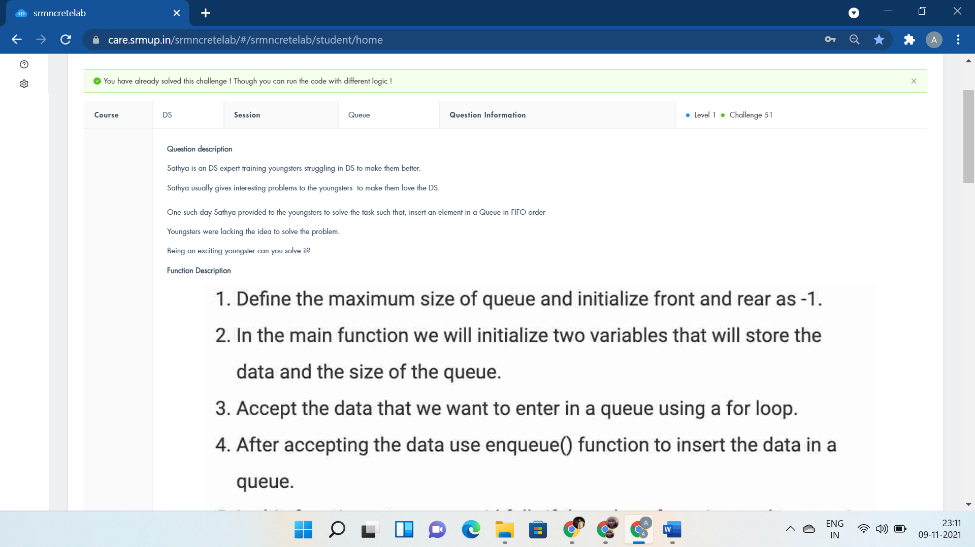

#include <stdio.h>

#define SIZE 100

void enqueue(int);

void display();

int items[SIZE], front = -1, rear = -1;

int main() {

int n,data,i;

scanf("%d",&n);

for(i=0;i<n;i++)

{

scanf("%d",&data);

enqueue(data);

display();

}

return 0;

}

void enqueue(int data) {

if (rear == SIZE - 1)

printf("Queue is Full!!");

else {

if (front == -1)

front = 0;

rear++;

items[rear] = data;

printf("Enqueuing %d\n", data);

}

}

void display() {

if (rear == -1)

printf("\nQueue is Empty!!!");

else {

int i;

for(i=front;i<=rear;i++)

printf("%d ", items[i]);

}

}

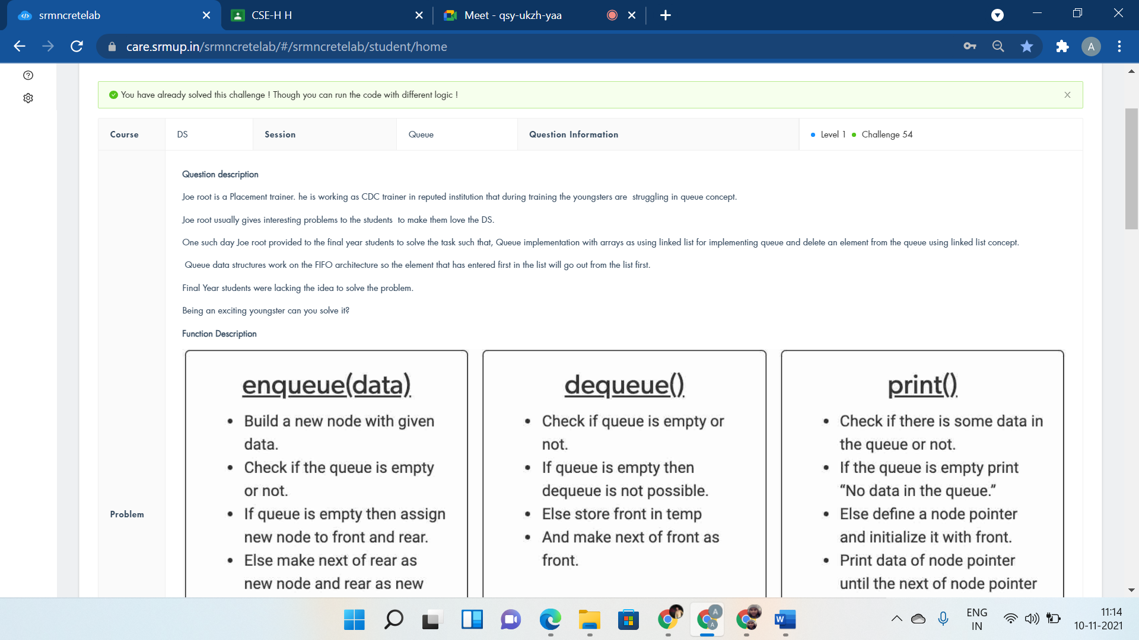

#include <stdio.h>

#include <stdlib.h>

struct node *front = NULL;

struct node *rear = NULL;

struct node

{

int data;

struct node *next;

};

void linkedListTraversal(struct node *ptr)

{

//printf("Printing the elements of this linked list\n");

while (ptr != NULL)

{

printf("%d ", ptr->data);

ptr = ptr->next;

}

}

void enqueue(int d)

{

struct node* new_n;

new_n = (struct node*)malloc(sizeof(struct node));

if(new_n==NULL){

printf("Queue is Full");

}

else{

new_n->data = d;

new_n->next = NULL;

if(front==NULL){

front=rear=new_n;

}

else{

rear->next = new_n;

rear=new_n;

}

}

}

int dequeue()

{

int val = -1;

struct node *ptr = front;

if(front==NULL){

printf("Queue is Empty\n");

}

else{

front = front->next;

val = ptr->data;

free(ptr);

}

return val;

}

int main()

{

int n,i,t;

scanf("%d",&n);

for(i=0;i<n;i++)

{

scanf("%d",&t);

enqueue(t);

}

linkedListTraversal(front);

dequeue();

printf("\n");

linkedListTraversal(front);

return 0;

}

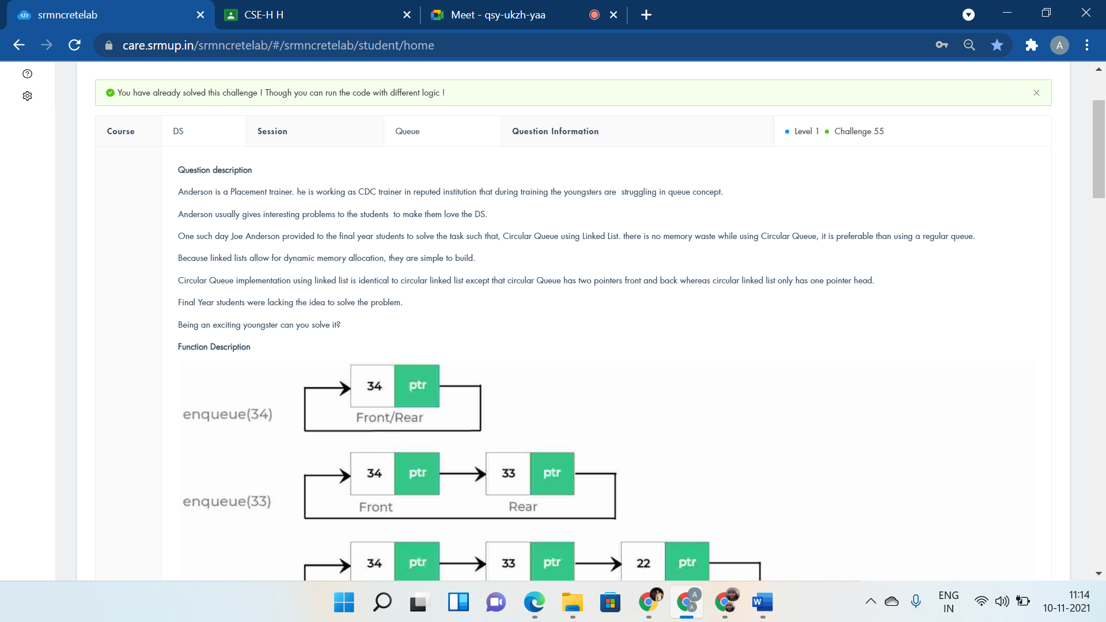

#include <stdio.h>

#include <stdlib.h>

struct node *f = NULL;

struct node *r = NULL;

struct node

{

int data;

struct node* next;

};

void enqueue(int d)

{

struct node *n;

n = (struct node*)malloc(sizeof(struct node));

if(n==NULL){

printf("Queue is Full");

}

else{

n->data = d;

n->next = NULL;

if(f==NULL){

f=r=n;

}

else{

r->next = n;

r=n;

}

}

}

int dequeue()

{

int val = -1;

struct node* t;

t = f;

if(f==NULL){

printf("Queue is Empty\n");

}

else{

f = f->next;

val = t->data;

free(t);

}

return val;

}

int main()

{

int n,i,t;

scanf("%d",&n);

for(i=0;i<n;i++)

{

scanf("%d",&t);

enqueue(t);

}

for(i=0;i<n;i++){

printf("%d\n",dequeue());

}

return 0;

}

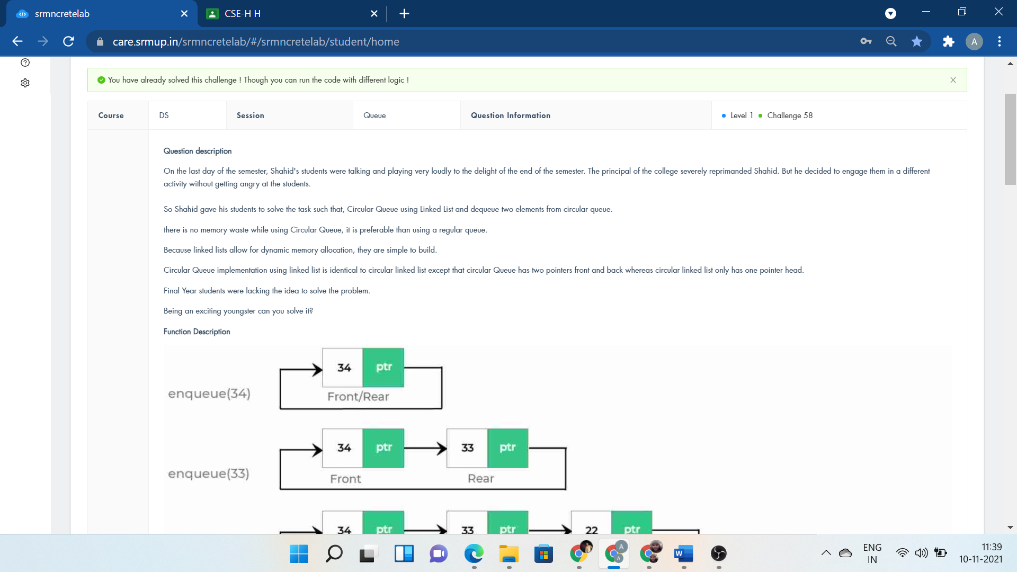

#include <stdio.h>

#include <stdlib.h>

struct node *f = NULL;

struct node *r = NULL;

struct node

{

int data;

struct node* next;

};

void linkedListTraversal(struct node *ptr)

{

//printf("Printing the elements of this linked list\n");

while (ptr != NULL)

{

printf("%d ", ptr->data);

ptr = ptr->next;

}

}

void enqueue(int d)

{

struct node *n;

n = (struct node*)malloc(sizeof(struct node));

if(n==NULL){

printf("Queue is Full");

}

else{

n->data = d;

n->next = NULL;

if(f==NULL){

f=r=n;

}

else{

r->next = n;

r=n;

}

}

}

int dequeue()

{

int val = -1;

struct node* t;

t = f;

if(f==NULL){

printf("Queue is Empty\n");

}

else{

f = f->next;

val = t->data;

free(t);

}

return val;

}

int main()

{

int n,i,t;

scanf("%d",&n);

for(i=0;i<n;i++)

{

scanf("%d",&t);

enqueue(t);

}

linkedListTraversal(f);

for(i=0;i<2;i++){

dequeue();

printf("\n");

linkedListTraversal(f);

}

return 0;

}



#include <stdio.h>

#include <stdlib.h>

struct node *front = NULL;

struct node *rear = NULL;

struct node

{

int data;

struct node *next;

};

void linkedListTraversal(struct node *ptr)

{

//printf("Printing the elements of this linked list\n");

while (ptr != NULL)

{

printf("%d ", ptr->data);

ptr = ptr->next;

}

}

void enqueue(int d)

{

struct node* new_n;

new_n = (struct node*)malloc(sizeof(struct node));

if(new_n==NULL){

printf("Queue is Full");

}

else{

new_n->data = d;

new_n->next = NULL;

if(front==NULL){

front=rear=new_n;

}

else{

rear->next = new_n;

rear=new_n;

}

}

}

int main()

{

int n,i,t;

scanf("%d",&n);

for(i=0;i<n;i++)

{

scanf("%d",&t);

enqueue(t);

}

linkedListTraversal(front);

return 0;

}